What I did on my summer vacation, or… swimming in the Antarctic Ocean.

When our expedition leader told us the doctor would be on the beach standing by, we understood somebody was taking this swimming thing too seriously. Hurtigruten offers swimming opportunities every Antarctic cruise, and usually about thirty Norwegians, for the most part, go for a swim in the 2 C (35 F) water. They keep reminding us that medical rescue is a 36 hour affair, so “don’t get hurt, don’t get appendicitis”.
We were instructed to dress in our bathing suits under our layers of thermals, fleece and woolens, as the penguins hadn’t provided a changing hut. In my case, just on my legs I wore long thermal liners under long thin woolen pants and Gore-Tex wind and waterproof storm pants over it all. On top, two layers of woolen undershirts, a fleece jacket then the light blue storm jacket Hurtigruten gave us the day we arrived. We also, of course, wore liner gloves and waterproof shell mittens, and liner socks then wool socks and rubber muck boots. And a wool hat, maybe under a hood or two. All this would need to be removed before swimming. And put back on afterwards.
(Full disclaimer here, the weather has been disconcertingly great, sunny and in the 30’s F, think global warming. So the massive dressing is mostly needed for the trips across the water in the rubber boats.)
When asked what the swimming situation would be, we were told there would be, in addition to the doctor, towels. But it seemed the doctor was only there to take our names before we ran into the water and to hand us a towel when we ran back out.
The opportunity was, of course, irresistible. Who wouldn’t want to go home bragging about swimming in Antarctica? They even told us they would give us an official certificate as proof. I love certificates.
So, I did it, after about an hour walking around photographing chinstrap penguins and fur seals, trying to build up courage. I wasn’t afraid of freezing to death. I’d be offered a towel, right? But the pain of it…
The most useful suggestion they had was to do it quickly and don’t think too much about it. Good advice. The water felt, as expected, like frozen knives slicing off your skin. But the bad part they didn’t mention was the sloping beach made up of 3-5 inch rounded ‘river’ stones that slid around and provided poor purchase for semi-frostbitten feet and you always felt off balance.
I didn’t stay in too long. Someone snapped about 10 pictures of me, but every one of the pictures captures my face in an unattractive silent scream.
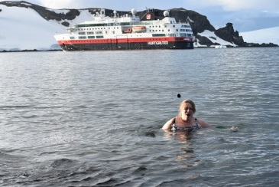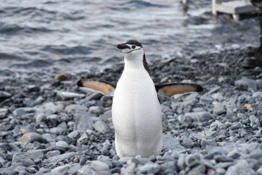
When I came out of the water the 35 F air felt positively warm. And the following day my certificate proof of Antarctic swimming (loosely defined in my case) was posted on the door of the cabin.
I’m proud of myself, not for jumping in the water like all the other dumb people, but for pushing myself into doing something extremely unpleasant, something unusual, and something that marks that day as an entirely different kind of day in my life. Without events that rise above the ordinary, what is there to remember?
My mother’s words come back to me: If everyone jumped off a cliff would you? Obviously… yes.

